**WASH Profile of Three Municipalities Prepared**

Publication Type: WASH Profile

Report Topic: WASH Profile of Kalyanpur, Karjanaha, and Siraha Municipalities of Siraha District

Client: © SABAL Nepal/Welthungerhilfe and Municipalities

Under the project, Strengthening Municipal wide WASH Governance for Social Change in Siraha district” a baseline survey was carried out at Census Level in Kalyanpur, Karjanaha, and Siraha Muncipality covering 34,896 households with 192,412 population. Based on more than 120 indicators 3 separate WASH Profiles were generated covering sub-sectors e.g. Access to Safe Drinking Water, Access to Improved Sanitation Facilities, Hand Washing and Personal Hygiene; Household Sanitation; Food Hygiene and Nutrition; Solid Waste Management; Waterborne Diseases; Menstrual Hygiene; and Accountability.

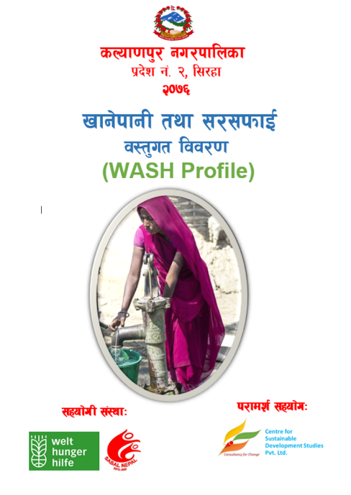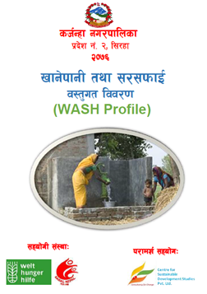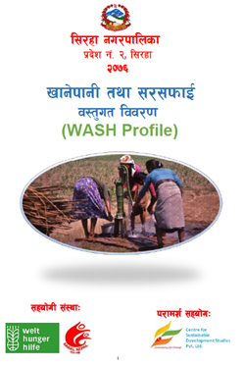

WASH Profiles PDF links